**TECHNICAL DOCUMENT.**

**Software Project Management.**

**Nkuraija Gary Matthew BSCS3.**

**S19B23/537.**

**LOGIN AND REGISTER.**

**Use-case 1: Login.**

A user is prompted to login for existing clients while new users are prompted to sign up.

If a user logs in to an existing account with a wrong Password or email, they are prompted with the message “Incorrect Password/Email”.

They can either create an account which once completed prompts the message “Account successfully created, await Admin Approval”.

**NOTE:** With a future feature update, Users with forgotten credentials will be prompted with links via respective email addresses to update/change the login credentials.

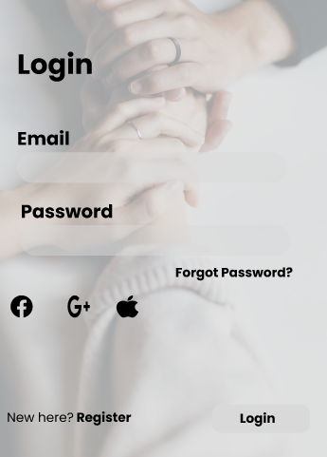 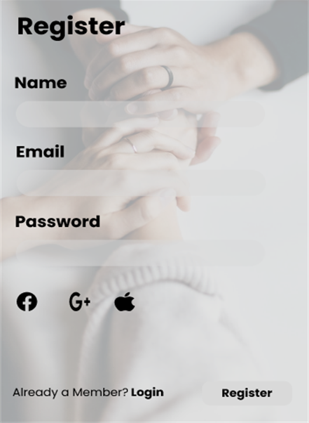

**Use-case 2: Client logs on**

Once a client has successfully signed-up for an account and it has been approved by the admin, they can login and the following screen is displayed

**USER MENU**

The main client menu will have the following options:

1. Talk to doctor.
2. Check Doctors nearby.
3. Check on Progress.
4. View Recommended reading materials.
5. See Doctors online.

It will also have a toolbar at the bottom of the page displaying Home, Conversations and Profile page links.

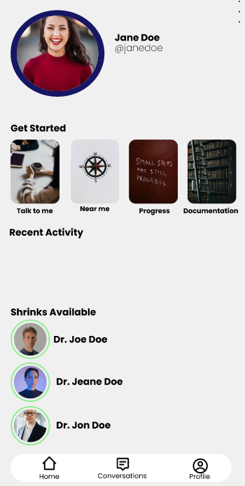

**CONVERSATIONS PAGE**

The conversations page will have a button to start a new conversation with a random doctor at the top with a list icon to select all messages upon which the user can perform actions such as delete and achieve.

It will also have a slide bar with doctors available and can chose who to talk to.

A search bar will be available for the user to get results based on the input.

A drop down of the messages that the user has had with previous doctors.

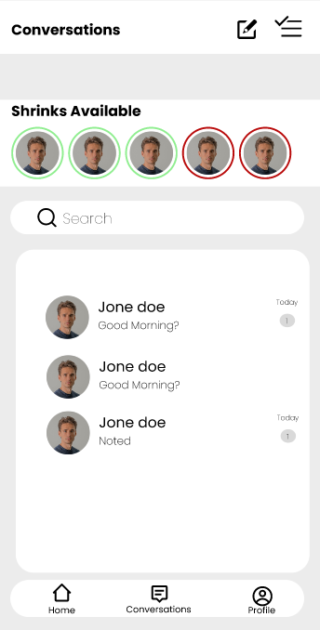

**Use-case 3: Talking to a doctor**

Once a user clicks the talk to a doctor option, a ten-question questionnaire is presented to assess the client’s state of mind. A score of <50, the user sees a counsellor. However, a score 50> the client is assigned a doctor as it is a critical.

When the session is done the doctor closes the request by writing a comment, then the patient’s bill is sent.

**PROFILE PAGE**

The page will have an eclipse of the user photo along with the name and username which can be edited using the edit icon.

It will also have links to the following pages.

1. My account.
2. Saved Beneficiary.
3. Face ID.
4. Two factor Authentication.
5. My Account.
6. Help and support
7. About app

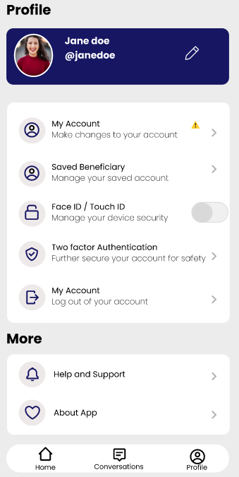

**CHARACTER OF THE SYSTEM TO BE DEVELOPED**

The system to be developed is a mobile application that will use Figma for the ui/ux design and flutter with Dart as the programming language to develop the back end of the application.

The application will have a simple design to enable users navigate through the system easily without losing interest and attention. Firebase Realtime Database will be used for the database along with Cloud Firestore to have a robust and secure database since the application deals with sensitive data.